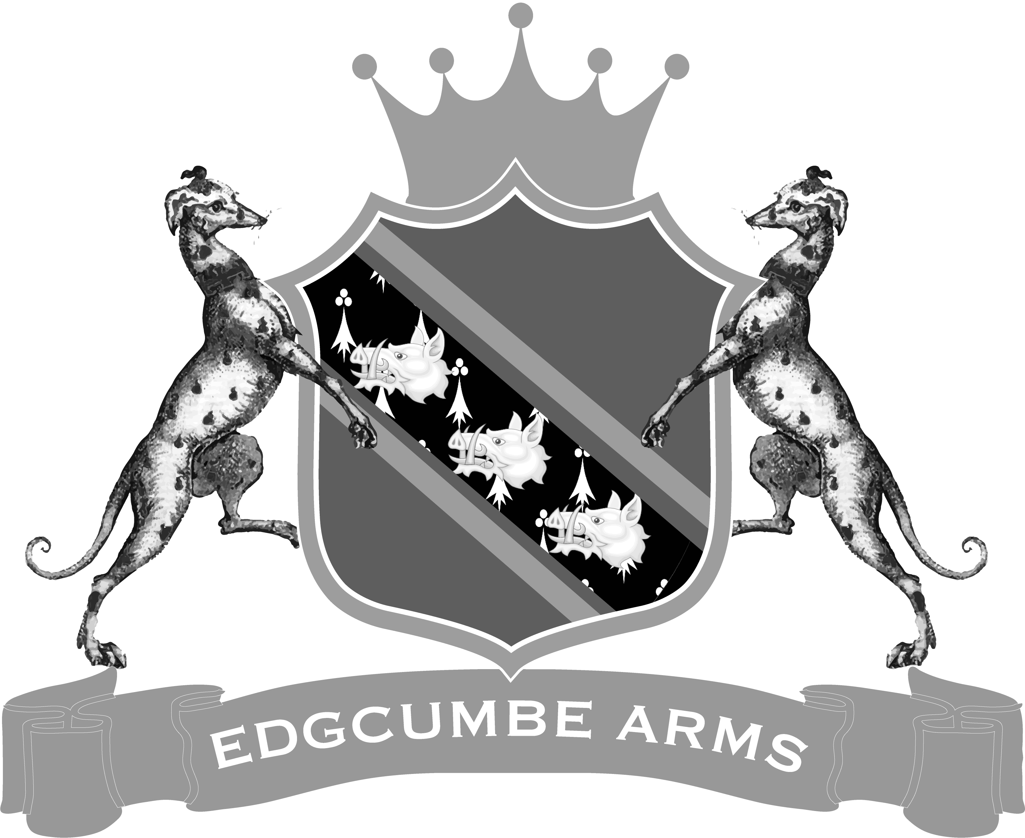

Cremyll, Cornwall Pl10 1Hx Tel 01752 822294

Congratulations on your upcoming wedding.
At the Edgcumbe Arms we cater for the smaller, more personal wedding ceremonies and receptions.
We are fully licensed for marriage ceremonies, renewal of wedding vows and civil partnerships. The ceremonies take place either upstairs in the Court room or downstairs on the Plinth.

Capacity for the wedding ceremony in the Court Room is 45/50 guests and 15/20 guests for the Plinth. Both areas have a seated meal capacity for 45/50 people and a buffet for up to 80 people.

We are happy to offer a variety of menu choices from a three course sit down meal to a more informal buffet, BBQ or afternoon tea. However, we can be flexible in what we offer and can arrange a menu to suit your requirements. Our menus start from £19.95 per head. Please contact us to discuss these options further.

Transport by ferry to and from Stonehouse in Plymouth can be arranged via Plymouth Boat Trips and they can be contacted through their website; www.plymouthboattrips.co.uk There is also a local taxi minibus service that can be hired from Kernow Coaches, who can be contacted by emailing: enquiries@kernowcoaches.com or call 01752 822200.

If you are looking to accommodate your guests we have two doubles, one twin and one double/family ensuite rooms, all with river views. Prices start from £70 per night based on two people sharing including a full Cornish breakfast. However, the prices do vary throughout the year, so please ask upon enquiry.
The cost of the function room hire starts at £375.00. Included in this price is your table linen. We can provide a wide range of colours and sizes. Don’t hesitate to ask if you have a specific colour in mind.
Please contact us on 01752 822294, or via email info@edgcumbearms.co.uk to
arrange a meeting.

